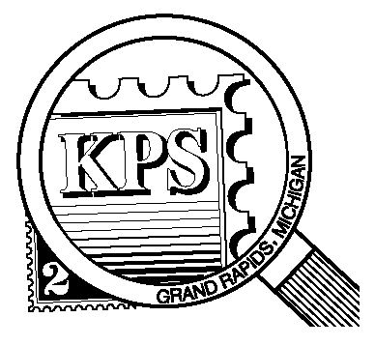

NEWSLETTER OF THE KENT PHILATELIC SOCIETY
P.O. Box 1156, Grand Rapids, Michigan 49501-1156
Louis Morel, President and Editor 269-420-3128
KentPhilatelicSociety.com

K.P.S. Philatelist
Volume 70- No. 5 May 2026

KPS Club News
Many philatelic organizations across North America have adopted electronic communications. Some, such as Linn’s Stamp News, have abandoned the print medium altogether. The KPS board has opted to send the monthly newsletter by email. This will ease the preparation and distribution of The Philatelist and provide cost savings for the club.  Members will receive the June issue in both print and electronic forms. The July issue of the newsletter will be sent in digital form only EXCEPT to those members who have contacted Louis Morel at the phone number in the masthead to indicate their preference for the print version.  Darrin Lettinga’s presentation during the March meeting had to be rescheduled due to a technical issue. We look forward to hearing Darrin’s offering in the near future.  This month’s meeting will feature Henry Barry’s presentation on a very special cover he purchased at the Great American Stamp Show in Chicago last year. It purports to have flown on the first North American flight of the airship Hindenburg. While the Hindenburg had been built specifically to exploit the prestigious passenger route between Europe and the United States, the dirigible had made a round trip between Germany and Rio de Janeiro only four weeks earlier. The Hindenburg carried a large amount of mail on its inaugural flight from | Europe to New Jersey. One of those covers led Henry down several deep rabbit holes. Henry will share some rather astounding detours and an incredible story about a stamp dealer!  Note that the presentation will start at 6:45 PM followed by the auction.  The spring Bourse will be held on May 9 at the American Legion Post in Walker. We are seeking volunteers willing to spend one hour to help with the setup on Friday night starting at 6 PM. Please let Bill Sobotka (616.531.3295) know if you are willing to contribute an hour of your time.  The third annual Summer Stamp Social will be held on July 11 at the Byron Center Baptist Church. There will be a mini-bourse (two dealers). Food and beverages will be served. We are seeking a member to chair the organizing committee. This person will oversee the acquisition of the food and non-food items as well as the layout of tables. We will need volunteers to help set up and tear down the event space. We will need volunteers at the registration desk to greet the visitors. We will need assistance with grilling and serving the food as well. Contact Bill Sobotka to add your name to the list.
The KPS Board will enhance our monthly auctions by holding a drawing for a FREE $10 certificate toward the winning purchases of one lucky member. You need to be present to participate in the drawing.

MONTHLY PROGRAM SCHEDULE
May 26, 2026: KPS CLUB MEETING  5:30 PM Board Meeting  6:30 PM Lot Viewing  6:45 PM Presentation and Floor Auction | June 23, 2026: KPS CLUB MEETING  5:30 PM Board Meeting  6:30 PM Lot Viewing  6:45 PM Presentation and Floor Auction
The Kent Philatelic Society meets on the 4th Tuesday of the month at the Byron Center Baptist Church, 7343 Byron Center Ave SW, Byron Center.

Members are invited to share their philatelic experiences in this space. Perhaps you made a special acquisition, or thrive on an uncommon collecting topic, or saw a remarkable exhibit. Share it with your fellow collectors. Contact the Editor with your stories.
Salem Poor: Contributor to the Cause
In the April 2022 edition of our newsletter (see Volume 66, no. 4), I submitted an article on Sybil Ludington who was recognized as one of the four “Contributors to the Cause” in a stamp set (Scott # 1559-1562) issued for the 1976 United States Bicentennial. Since we are celebrating the 250th anniversary of our independence this year, it seems appropriate to complete the information for the other three stamps in this set, the first of which is the Salem Poor stamp.

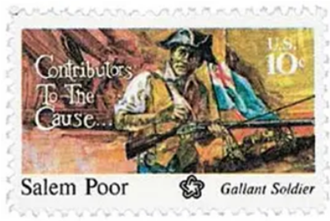
Born in Andover, Massachusetts, Salem Poor (1747-1802), shown at right loading a musket, (Scott no. 1560) was an African American slave who bought his freedom at age 22 for 27 pounds. He became a soldier, and gained fame as a war hero at the Battle of Bunker Hill on June 17, 1775. General Washington initially banned black men from the Continental Army but reversed his decision after the Governor of Virginia, Lord Dunmore, offered freedom to slaves serving the British. This caused Washington to change his position and ordered all recruiters to enlist any black man who wanted to fight.

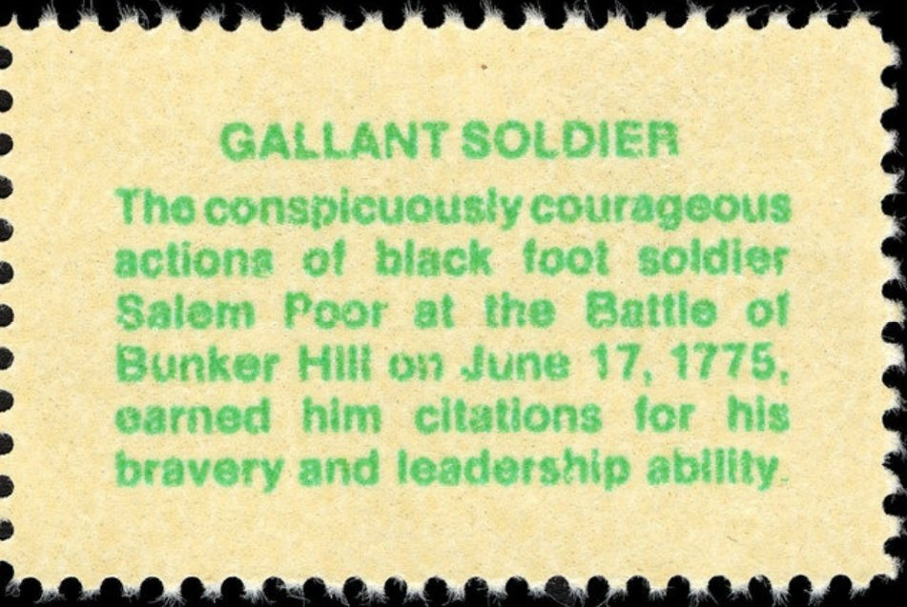
A description of the design is printed in green on the reverse of each stamp in this set, beneath the gum. On the reverse of the Salem Poor stamp is written “Gallant Soldier. The conspicuously courageous actions of black foot soldier Salem Poor at the Battle of Bunker Hill on June 17, 1775, earned him citations for his bravery and leadership ability.”

Salem Poor, along with other soldiers, built a fort on Breed’s Hill. Poor is remembered for his actions during the Battle of Bunker Hill where he was credited with mortally wounding British Lieutenant Colonel James Abercrombie during that Battle (USA, Scott no.1564 issued to commemorate the 200th anniversary of the Battle, shown nearby).

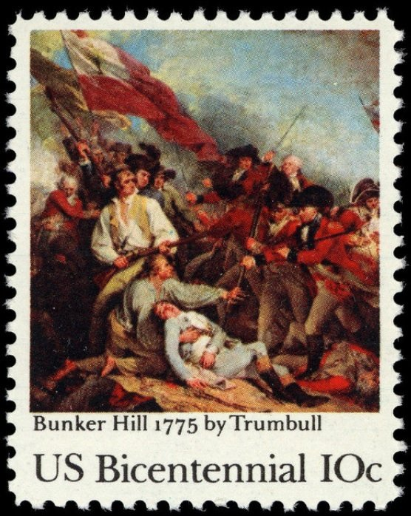
The image used for the stamp is a reproduction of a painting by John Trumbull (1756-1843).

His bravery and heroism were recognized by 14 Continental Army officers, who petitioned the Massachusetts General Court to reward him for his distinguished service. No other soldier received such recognition. There is no evidence that Poor received a reward.

Poor re-enlisted in 1776 under General Benedict Arnold for three years and spent his time in Saratoga, New York. In 1777–1778, he was at the winter camp at Valley Forge and fought in the Battle of White Plains. He fought in several key battles, including those at Saratoga and at Monmouth, New Jersey, before being discharged in 1780 in Providence, Rhode Island.

Poor married four times. In August 1771, he married freed woman Nancy Parker who was half Native American and half African American. They had one son in 1775. He married his second wife, Mary Twing, also a free African American, in 1780. They were ordered to leave Andover, presumably because they could not support themselves. By 1785 the marriage was over and Salem married a white woman, Sarah Stevens, in 1787. He was briefly jailed for "breach of peace" in 1799 and married for the fourth and final time in 1801. He wed Hannah Ayliffe, a Black woman of unknown status.
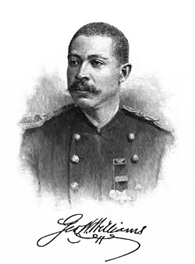
In 1876, in a speech at the time of the United States' centennial celebration, George Washington Williams (shown at right), who served in the Ohio House of Representatives, commemorated Poor and other African American soldiers who fought at Bunker Hill.

He was one of at least 5,000 African Americans who served on the side of the Colonists throughout the Revolutionary War. Many more African Americans chose to enlist in the British Regular Army.

Salem Poor died in 1802. He was buried at Copp’s Hill Burying Ground in Boston, but his grave remains anonymous and the exact location remains a mystery to this day. Poor Street in Andover, Massachusetts, was named after him.

Dan Ondersma

